
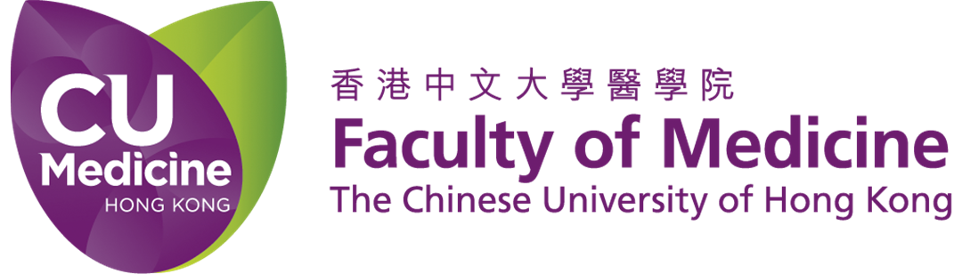
Pan-Asia Endoscopic Ear Surgery Forum &
12 – 13 November 2017
2nd Endoscopic Ear Surgery & Temporal Bone Dissection Workshop 2017
14 – 16 November 2017
Prince of Wales Hospital, Hong Kong

Registration Form

Complete this registration form in BLOCK LETTERS and return it with the appropriate registration fee to the Secretariat (we accept fax and on-line registration for credit card payment). Places will be confirmed on receipt of completed registration form and full payment.

Title* □ Prof □ Dr □ Mr □ Mrs □ Ms

First Name* __________________________ Last Name* ______ ________________________

Institution* ________________________________________________________________________

Mailing Address* ___________________________________________________________________

__________________________________________________________________________________

Tel* ____________________ Fax _________________ Email* __________ _______________

Registration category(HKD)*
Pan-Asia Endoscopic Ear Surgery Forum (12 – 13 November 2017)
 | On/Before 6 September 2017 | After 6 September 2017
◻ ENT Specialist | $2,000 | $2,500
◻ ENT Trainee#/ ◻ Nurse | $1,000 | $1,250
◻ Nurse (Hong Kong Hospital Authority) | $750 | $750
◻ Gala Dinner (12 Nov) | $780 per person x _____ = $___________
2nd Endoscopic Ear Surgery & Temporal Bone Dissection Workshop (14-16 November 2017)
 | Hands-on | Observer
Group 1/2: Temporal Bone Dissection & Basic Endoscopic Ear Dissection
Please choose your level: BST/ HST (year 1-2) | ◻ $20,000 | ◻ $2,000
HST (year 3-4) | ◻ $20,000 | ◻ $2,000
Group 3: Advanced Endoscopic Ear Surgery Dissection | ◻ $25,000 | ◻ $2,500
Group 4: One-day Endoscopic Ear Surgery Dissection  Please mark your preferred date  (1 is preferred, 2 is second choice, 0 is not preferred)  ◻ 15 Nov ◻ 16 Nov | ◻ $10,000 | ◻ $1,000
Grand Total | HK$
# Proof required.

Dietary Preference : ◻ Regular ◻ Vegetarian ◻ Others (pls specify __________________)

Payment Method*
□Bank Draft: a bank draft payable to “The Chinese University of Hong Kong” is enclosed.
(Personal cheques are acceptable for HK residents ONLY)

□ Credit Card: Visa / Master@ (@delete as appropriate)
Name of Card Holder ____ ___________________
Card No _______-_______- ______-_______ Expiry date ____/____
Amount HKD ____________
Signature ____________________ Date_________________________
* Required field
Protection of Personal Data
The Department of Otorhinolaryngology, Head and Neck Surgery of The Chinese University of Hong Kong (“Department”) organizes academic and educational activities. The Department intends to use the personal data (i.e. your name, email and mailing addresses and contact number) you provided in this form for the purpose of sending you the Department’s promotional and educational information.

Please tick the box to indicate your consent:
- I agree that “Department” uses my name, email address and contact number (if applicable) for the purpose of sending me Department’s promotional and educational information.

□ I do not wish that “Department” uses my name, email address and contact number (if applicable) for the purpose of sending me Department’s promotional and educational information.
Conference participants have the right to request access to and correction of their personal data held by the “Department”. Please send the request to Conference Secretariat by fax (852)2145 8876, by email at hktees@ent.cuhk.edu.hk, or by mail to the Department of Otorhinolaryngology, Head and Neck Surgery, The Chinese University of Hong Kong, Prince of Wales Hospital, Shatin, Hong Kong.

Payment, Cancellation and Refund Policy
- Please note that full payment must be received with completed registration form.
- All cancellations must be made in writing to the Secretariat. The following refund policy will be observed:

Postmarked, faxed or email on or before  13 September 2017 | Refund of registration fee less an administration charge of HK$450
Postmarked, faxed or email after  13 September 2017 | No refund

Should the Forum / Workshop scheduled have to be cancelled due to unforeseeable circumstances, the organizer shall try to reschedule the programme whenever possible. There will be no refund if the delegate cannot attend the re-scheduled programme. If, for reasons beyond the control of the Organizing Committee, the Forum / Workshop is cancelled, registration fees will be refunded after the deduction of conference expenses already incurred.

Conference Secretariat
Department of Otorhinolaryngology, Head and Neck Surgery,
The Chinese University of Hong Kong, Prince of Wales Hospital, Shatin, N.T. Hong Kong
Tel: (852) 3505 1277 Fax: (852) 2145 8876 Email: hktees@ent.cuhk.edu.hk
Website: www.ent.cuhk.edu.hk/hktees

